**Assignment Solution**:

Designing Inclusive User Interfaces

**Chosen User Group**: Users with hearing impairments.

**Digital Product**: Seizure Detection App

**Analysis of Cognitive and Perceptual Characteristics:**

* Users with hearing impairments may have difficulty perceiving auditory cues or alarms.
* They may rely heavily on visual information and tactile feedback.
* Considerations we include visual alerts, text-based notifications, and alternative communication methods.

**Design Concept:**

* Redesigning the seizure detection app to prioritize accessibility for users with hearing impairments.
* Implementing visual and tactile feedback mechanisms to supplement auditory alerts.
* Providing customizable alert settings and alternative communication options.

**Design Prototype:**

* 1. Sign up page.
  2. Login page.
  3. Registration page.
  4. Edit profile.
  5. Change password page.
  6. Home page.
  7. Advice page.
  8. Patient list page.
  9. Relative list page.
  10. About us page.
  11. Feedback page.

Strong password

**"Some examples in the prototype have been applied to the 8 golden rules:"**

* 1. Strive for consistency & offer informative feedback.

* 1. Design dialogs to yield closure.

* 1. Prevent errors.

* 1. Permit easy reversal of actions.

* 1. Keep users in control.

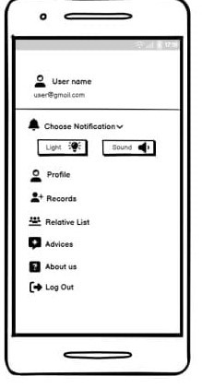

**Design Rationale**:

* Visual and tactile feedback mechanisms supplement auditory alerts to ensure users with hearing impairments can effectively receive important notifications.
* Customizable alert settings and alternative communication methods provide flexibility to accommodate individual preferences and needs.
* Clear, concise text explanations and visual representations enhance understanding and usability for users with hearing impairments.

**Reflection**:

* Redesigning the seizure detection app to prioritize accessibility for users with hearing impairments required careful consideration of visual and tactile feedback mechanisms.
* This assignment highlighted the importance of designing inclusive user interfaces that accommodate diverse user needs and preferences.
* Moving forward, exploring additional features such as customizable vibration patterns and alternative communication methods can further enhance the accessibility and usability of the app for users with hearing impairments.